Meet the Preschool Teachers

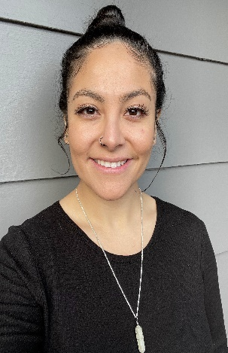Ms. Ashley

Hello, my name is Ashley and I have been working in early childhood education for about six years. I originally went to school for nursing but shortly realized my passion was with children. I am fluent in Spanish and was born in Guadalajara Jalisco, Mexico and moved to Washington when I was 3. I love camping and painting. I cannot wait to meet and work with your children!

Ms. Justine

 My name is Justine and I’m a 23-year-old from Denver, CO. I moved up to Tacoma 5 years ago to go to the University of Puget Sound. I love painting (usually portraits) as well as hiking and camping around the PNW. I also have a passion for psychology and mental health, which is why I volunteer as a grief support facilitator for children at Mary Bridge Children’s Hospital. I love hanging out with kids and am so excited to be a part of the NTMC team!



Meet the Preschool Teachers Cont.

Ms. Kaitlyn (Kate)

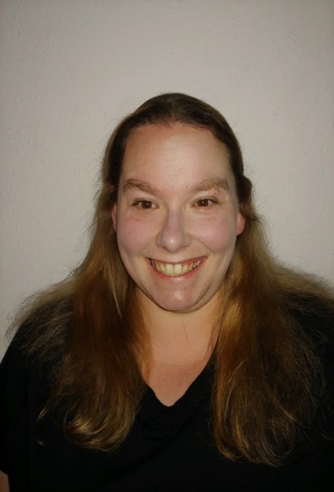 Hello, my name is Kate! I have been a preschool teacher for about 8 years now. I have my Montessori and Early Childhood Education degree from Green River College. I also have my bachelor’s degree in history from Western Washington University. I have lived in Washington all my life and am a baker, coffee addict, gamer, reader and world traveler. My favorite quote to live by is “The more you read, the more things you will know. The more that you learn the more places you’ll go.” – Dr. Seuss I cannot wait to get to know you and your children!

Meet the Waddler Teachers

Ms. Mariah

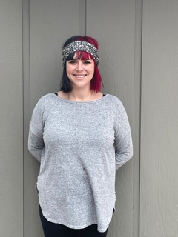Hello! My name is Mariah, and I am new to the NTMC family. I have spent most of my life in Huntington Beach, CA but my heart belongs to the Pacific Northwest and New York City. I have a blonde surfer dude 4-year-old as well as a sassy 3-year-old princess. If we are not spending time with our fur babies Chewie, Mystery and Calypso, then we are out in nature exploring. We love to find rocks and explore new places. I am so excited to be a part of the nature center and cannot wait to spend time watching your little ones grow!

Meet the Toddler Teachers

Ms. Tiana

Hello! My name is Tiana.  I have been a part of the NTMC family for over a year and am looking forward to many more to come! I have a 2-year-old daughter named Stella who attends NTMC at our Proctor location. I have worked with children of every age range and have fallen in love with toddlers. I have a strong passion for children and all things nature, so I am incredibly grateful to be a part of the nature center. I look forward to getting to grow right alongside your little ones!

Ms. Kamrey

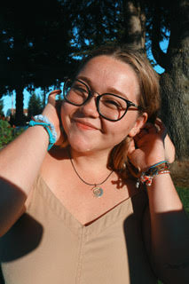Hi, I am Kamrey! I am recently graduated from The University of Puget Sound with a degree in Sociology and Anthropology/ Education. I grew up in a small town in Minnesota called Northfield and moved out here when I started school. My passions are education, dancing, and spending quality time with the people I love! I am new to North Tacoma Montessori but have been working in Montessori schools for about 6 years now, and I am so excited to meet all the kids and watch them grow and learn!

Meet the Infant Teachers

Ms. Victoria

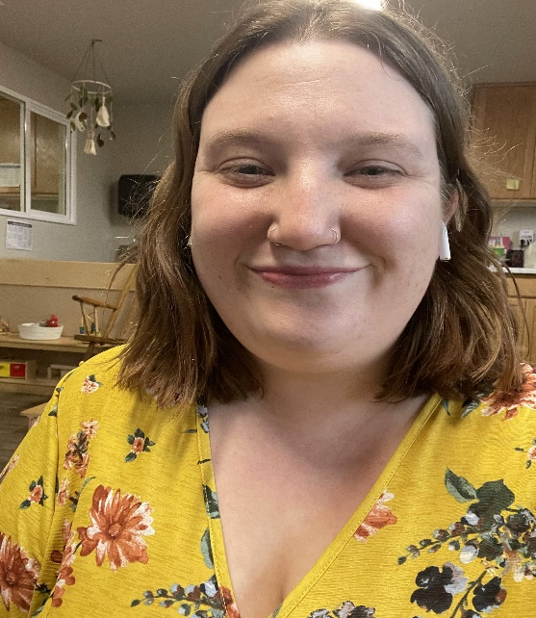 Hello! I am Victoria. Tacoma has been my home for my entire life with my dad and sister and I was born on April 1(an April Fool’s baby!).

I have worked in childcare for almost 5 years as of May 2021. Working with infants and junior toddler’s is my favorite age although I have experience in infant to school-age classes. My preferred lessons that I enjoy doing with the kids are art and sensory play.

A few facts about myself; I am a very spiritual individual and all about the mind body and soul while using natural remedies in everyday life. I love collecting houseplants and have many at home. I cannot wait to get to know you and your children and watch them grow!

Ms. Shelly

Hi, I am Shelly, I have been in childcare for 22 years. I enjoy working with children, it has been my passion since I was a little girl. I have my CDA and am going to be working on my Montessori education certificate, then work on earning my ECE credential. I am a proud mom of four wonderful grown-up children and have a loving husband. Some fun facts about me are my favorite color is purple, favorite season is Spring, birthday is December 1st, favorite movie is Dirty Dancing and my favorite drink is diet Dr. Pepper. I cannot wait to work with you and your children!

Meet the Director

Ms. Kelci

 Hello! My name is Kelci and I have been with NTMC since 2017! I have worked in childcare and education for 6 years and have my infant/toddler Montessori certification as well as a BS degree in Anthropology, a MS degree in Children, Youth and Family studies, am a certified Nature School teacher and currently working on my Ed.D in Educational Leadership! When I am not at school or work I enjoy spending time with my daughter and husband and our myriad of pets. I love to garden, collect plants, go on outdoor adventures, enjoy a cup of coffee and make future travel plans. I love getting to work with children each day and am looking forward to working with you through the start of their education!