Meet the Preschool Teachers

Ms. Darcy
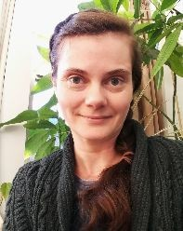
Greetings NTMC III Families!
My name is Darcy Anderson and I am one of your extremely excited PRE-K Nature Teachers. What a pleasure it is to be a part of this amazing community. For me, jumping into the role of Nature Guide/ Montessori Teacher feels like lacing up a pair of familiar old hiking boots, ready to head out on a favorite trail. I have always felt deeply rooted in the lush landscape of the Pacific Northwest. My husband and I grew up in Southeast Alaska and felt Tacoma possessed the perfect combination of urban culture, access to natural beauty and local small-town charm reminiscent of our upbringing. We have now been here for seventeen years and are proud to be raising our 12-year-old, Max! Throughout my 20+ years working with children I have experienced a variety of fulfilling positions, but it was in 2006 that I began my career in early childhood education and found a family with NTMC. Since then, I have blended my art practice and Montessori background with educational STEAM programming, started a creative local business (Tinkertopia, Creative Reuse Center), had a brief stint as a public library circle time storyteller (puppetry and ukulele playing are helpful hobbies), and am now moving full circle, back to my roots of nurturing children in nature. With a Nature Preschool/forest school certification, I am thrilled to be a part of this amazing new school and your children’s lives as we explore the world around us. From mud puddles, spruce tips, rain pants and slug trails, to the patterns of veins on leaves and the tracks of deer on trails, this will be a remarkable time to grow and learn outside!

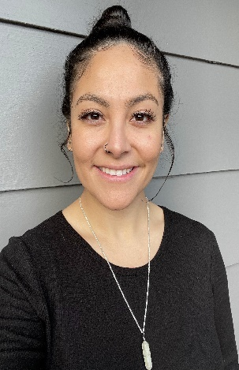
Ms. Ashley

Hello, my name is Ashley and I have been working in early childhood education for about six years. I originally went to school for nursing but shortly realized my passion was with children. I am fluent in Spanish and was born in Guadalajara Jalisco, Mexico and moved to Washington when I was 3. I love camping and painting. I cannot wait to meet and work with your children!

Ms. Justine

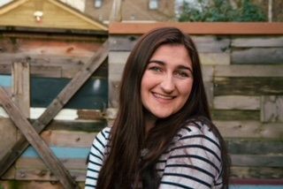
My name is Justine and I’m a 23-year-old from Denver, CO. I moved up to Tacoma 5 years ago to go to the University of Puget Sound. I love painting (usually portraits) as well as hiking and camping around the PNW. I also have a passion for psychology and mental health, which is why I volunteer as a grief support facilitator for children at Mary Bridge Children’s Hospital. I love hanging out with kids and am so excited to be a part of the NTMC team!

Meet the Waddler Teachers
Ms. Mariah

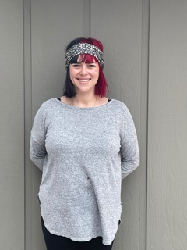
Hello! My name is Mariah, and I am new to the NTMC family. I have spent most of my life in Huntington Beach, CA but my heart belongs to the Pacific Northwest and New York City. I have a blonde surfer dude 4-year-old as well as a sassy 3-year-old princess. If we are not spending time with our fur babies Chewie, Mystery and Calypso, then we are out in nature exploring. We love to find rocks and explore new places. I am so excited to be a part of the nature center and cannot wait to spend time watching your little ones grow!

Meet the Toddler Teachers

Ms. Tiana

Hello! My name is Tiana. I have been a part of the NTMC family for over a year and am looking forward to many more to come! I have a 2-year-old daughter named Stella who attends NTMC at our Proctor location. I have worked with children of every age range and have fallen in love with toddlers. I have a strong passion for children and all things nature, so I am incredibly grateful to be a part of the nature center. I look forward to getting to grow right alongside your little ones!

Ms. Taryn
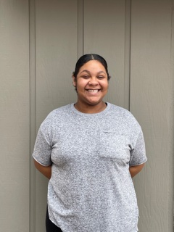

Hello families! My name is Taryn Humes-Louderback and I am 21 years old! I have been in early childhood education for 3 years and have spent the last 2 years working in Montessori schools. I have my associate degree in Early Childhood Education and am in school pursuing an associate degree in medicine. I have a strong passion for kids and the “aha” moments they have at life as they become little humans in our world! They are bright and beautiful, and I am blessed to a part of their life!

Ms. Kamrey

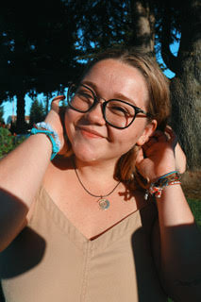
Hi, I am Kamrey! I am currently a senior at The University of Puget Sound studying Sociology and Anthropology/ Education and graduating in the Spring. I grew up in a small town in Minnesota called Northfield and moved out here when I started school. My passions are education, dancing, and spending quality time with the people I love! I am new to North Tacoma Montessori but have been working in Montessori schools for about 6 years now, and I am so excited to meet all the kids and watch them grow and learn!

Meet the Infant Teachers

Ms. Victoria

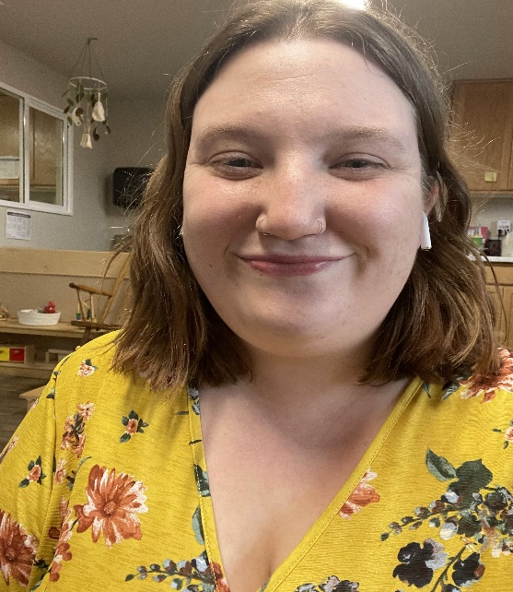
Hello! I am Victoria. Tacoma has been my home for my entire life with my dad and sister and I was born on April 1(an April Fool’s baby!).
I have worked in childcare for almost 5 years as of May 2021. Working with infants and junior toddler’s is my favorite age although I have experience in infant to school-age classes. My preferred lessons that I enjoy doing with the kids are art and sensory play.
A few facts about myself; I am a very spiritual individual and all about the mind body and soul while using natural remedies in everyday life. I love collecting houseplants and have many at home. I cannot wait to get to know you and your children and watch them grow!

Ms. Maddi

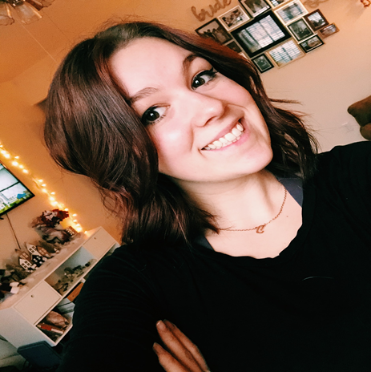
I was born and raised outside of Portland, Or, and have always known I have wanted to be a teacher. Since I was seven years old, I have had a passion for working with children and was babysitting for my parent’s friends as soon as I was able. By the time I was eighteen I was a full-time Pre-Kindergarten teacher at a Montessori school in Lake Oswego, where I worked for two-and-a-half years before moving to Washington with my husband, Caelan. Since then, I have continued to teach in both Montessori and Reggio settings and am incredibly happy to find myself with NTMC. I recently graduated from Prescott College with my Bachelor’s in Elementary Education and a minor in English. I am also a member of Sigma Tau Delta, the National Honors English Society.
In my spare time, I absolutely love to cook and can always be found in my kitchen or watching something on the food network. I enjoy going to the Oregon coast with my husband and our two dogs, Chloe and Jax, whenever possible as being by the ocean always helps to reset me. Currently, I am working on learning Spanish as well as the piano in the free time I now find myself with since graduating. I believe love and care for nature is one of the most important things we can instill in children and am excited to bring these aspects into the infant classroom.

